Example 6. A printer need to make a poster that will have a total area of 200 in2 and will have 1 inch margins on the sides, a 2 inch margin on the top and a 1.5 inch margin on the bottom as shown below. What dimensions will give the largest printed area?

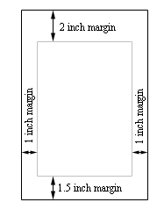

y

x

Sol:

Assume

the height of printed area y

the width of printed area x

(x+1+1)(y+2+1.5)=200

Max F(x,y)

F(x,y)=x\*y

1. One dimensional derivative

(x+2)(y+3.5)=200

x+2=200/(y+3.5)

x=200/(y+3.5)-2

F(x,y)=x\*y

F(y)=[200/(y+3.5)-2]\*y

Y~= 15.2

2.partial derivative

Max F(x,y)

F(x,y)=x\*y

Code:

<https://en.wikipedia.org/wiki/Gradient_method>

Gradient Descent梯度下降法

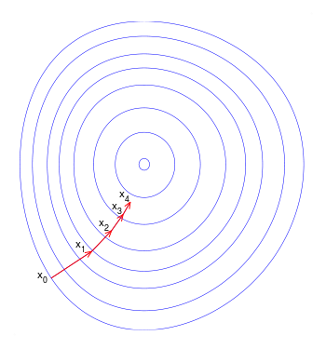

<https://www.google.com.tw/imgres?imgurl=https://upload.wikimedia.org/wikipedia/commons/thumb/f/ff/Gradient_descent.svg/350px-Gradient_descent.svg.png&imgrefurl=https://en.wikipedia.org/wiki/Gradient_descent&h=375&w=350&tbnid=bi71cz2ioWcGmM:&q=gradient+method&tbnh=160&tbnw=149&usg=AI4_-kRoF5hecwMdxnilZJB1IbGrrL2DfQ&vet=12ahUKEwjAyLCh-vDeAhVFXbwKHYsjAmMQ9QEwAHoECAQQBg..i&docid=H6_GiOPyBRo-zM&sa=X&ved=2ahUKEwjAyLCh-vDeAhVFXbwKHYsjAmMQ9QEwAHoECAQQBg>